Title of paper {centered, 14pt. Bold}
1st Author ^{1,*}, 2nd Author ², 3rd Author ², and 4th Author¹{centered, 12pt.}
{return twice after the last author then begin with the first heading or sentence}

¹ Division name, Institute Name, Street address, City Postal-code, Country
² Division name, Institute Name, Street address, City Postal-code, Country
* Corresponding author’s E-mail
{centered, 11 pt. italic}

Abstract { left aligned,11pt},These instructions give you basic guidelines for preparing papers for the ICP2M2015 Proceedings. Papers have 6-8 pages must be submitted using this format. This document is a template for Microsoft Word. If you are reading a paper version of this document, please download the electronic file from the IAP2M website so you can use it to prepare your manuscript. Abstract should be 150-200 words.
Keywords Aaa, Vvv, Www, Xxx, Yyy, Zzz {left aligned,11pt}
{Words in the title and “Project, Program Management” should not be used
as Keywords.}
(Space)
I. INTRODUCTION
(Space)
Your goal is to simulate, as closely as possible, the usual appearance of typeset papers in the ICP2M2015. One difference is that the authors’ affiliations should appear immediately following their names – do not include your title there.

(Space)
Level A, left aligned, 12 pt. bold}
(Space)
Level B - {left aligned, 11 pt. bold}
(Space)
Level C - {left aligned, 11 pt. italic}
(Space)

II. METHODOLOGY {Level A, left aligned, 12 pt. bold}

Sample {Level B, left aligned, 11 pt. bold}

- Type sizes and typefaces {Level C, left aligned, 11 pt. italic}:

The best results will be obtained if your computer word processor has several type sizes. Try to follow the typefaces and sizes specified in following guidelines as best as you can.

- Format:

Font Times New Roman should be used for the whole paper.
- Title : centered, 14pt. bold
- Name(s) of author(s): entered, 12 pt. italic
- Affiliation(s) and corresponding author’s e-mail: centered, 11pt, italic.
- Headings: The paper should have no more than 3 levels of headings (excluding the title and name(s) of author(s)).
  - Level A headings: left aligned, 12 pt. bold
  - Level B headings: left aligned, 11 pt. bold
  - Level C headings: left aligned, 11 pt. italic
- Page Layout

- Paper size : A4 size (21.0×29.7 cm)
- Single-spacing in a single-column format
- Top and bottom margins: 2.5 cm
- Left and right margins: 2.5 cm
- Footer/Header: Header and footer cannot be used.

III. RESULTS

Figures and Tables

All figures and tables including charts, graphics and photographs should be numbered respectively, such as Fig. 1 and Table 1. The numbers are in order in which they appear in the text consecutively. Titles and explanation of figures and tables must be written in the same language as the text. Title and explanation should be made easy to understand what they show without referring to the text. Color figures and tables are not acceptable.
Figures and tables should be included in the manuscript. It is recommended to place figures and tables in frames at the center of the margin. Lettering should be legible. The 10 pt or larger size is recommended for the letters.
Table 1. Headings.
Level | Position | Size(pt.) | Style
A | Left aligned | 12 | Bold
B | Left aligned | 11 | Bold
C | Left aligned | 11 | italic

The caption to every figure should be typed below the figure being justified. The caption to every table should be typed above the table with centering. 11 pt-sized letters are recommended for the figure/table captions.
Cite the figures and tables in the text with references such as “Fig. 1”, “Figs. 2(a)–2(b)”, and “Table 1”, etc.
Graphics should be 600 dpi (1 bit/sample) for line art (graphics, charts, drawings or tables) and 220 dpi for photos and gray scale images.

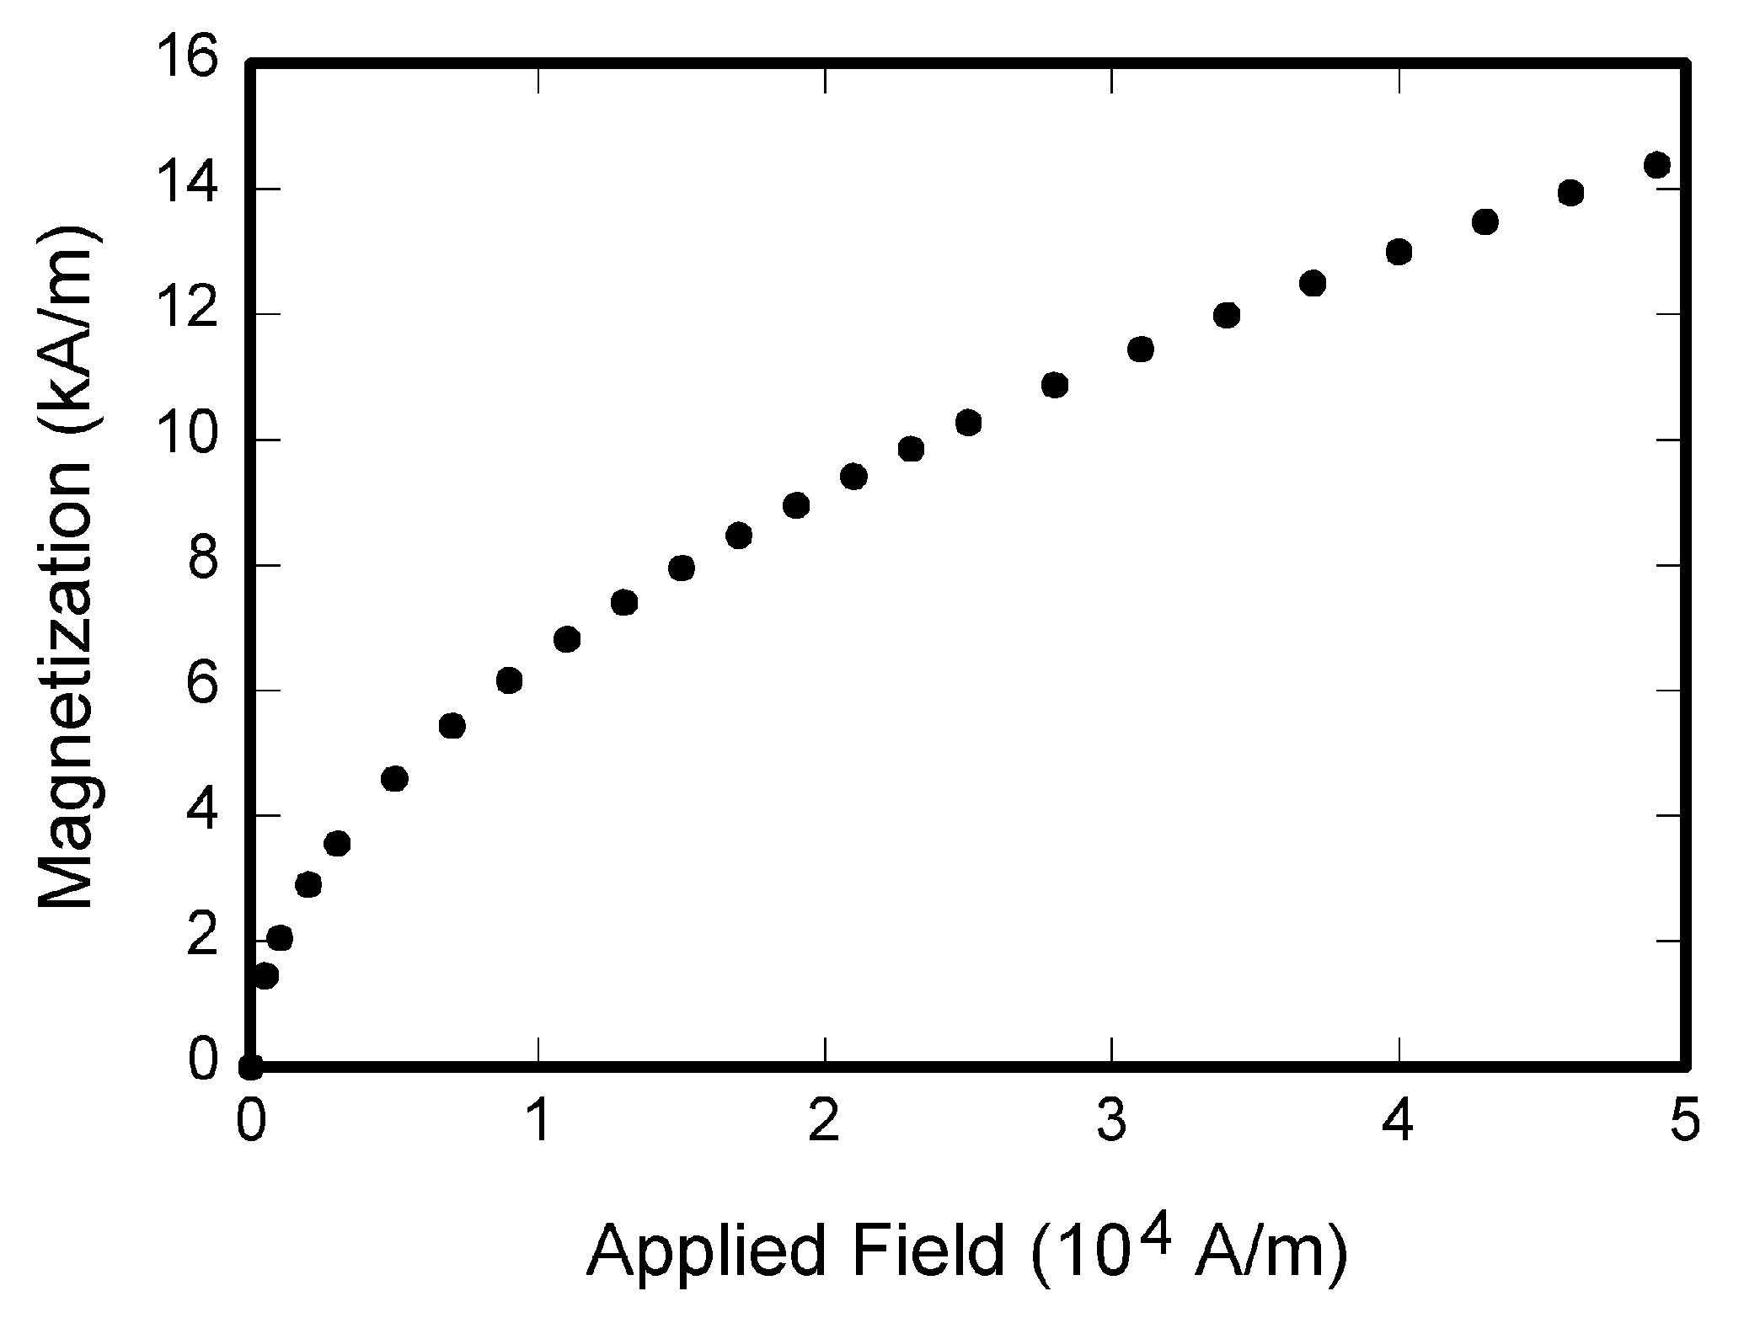
Fig.1 Magnetization as a function of applied field.

Equations

Equations should be typed, although you can embed Equation Editor or other objects if the equation cannot be typed in a line. They should be centered and separated from the text by two half-height blank lines above and below the equation. See the example as follows:
$y=x+3z$ (1)
Center tabs and right tabs are used in these examples. The equations should be numbered consecutively throughout the paper. The equation number should be placed in parentheses (round brackets) at a position near to the right margin (see example).

C. Other Recommendations

The Roman numerals used to number the section headings are optional. If you do use them, number INTRODUCTION, but not ACKNOWLEDGMENT and REFERENCES, and begin Subheadings with letters. Use one space after periods and colons. Hyphenate complex modifiers: “zero-field-cooled magnetization.” Avoid dangling participles, such as, “Using (1), the potential was calculated.” Write instead, “The potential was calculated using (1),” or “Using (1), we calculated the potential.”
Use a zero before decimal points: “0.25,” not “.25.” Use “cm³,” not “cc.” Indicate sample dimensions as “0.1 cm × 0.2 cm,” not “0.1 × 0.2 cm².” The abbreviation for “seconds” is “s,” not “sec.” Do not mix complete spellings and abbreviations of units: use “Wb/m²” or “webers per square meter,” not “webers/m².” When expressing a range of values, you should write “7 to 9” or “7-9” not “7~9”. Spell units when they appear in text: “…a few Henries,” not “…a few H.” If your native language is not English, try to get a native English-speaking colleague to proofread your paper. Number each page at bottom, right corner.

IV. DISCUSSION

Use either SI (MKS) as primary units. (SI units are strongly encouraged.) English units may be used as secondary units (in parentheses). This applies to papers in data storage. For example, write “15 Gb/cm² (100 Gb/in²).” An exception is when English units are used as identifiers in trade, such as “3.5-inch disk drive.”
Avoid combining SI and CGS units, such as current in amperes and magnetic field in ousted. This often leads to confusion because equations do not balance dimensionally. If you must use mixed units, clearly state the units for each quantity that you use in an equation.

V. CONCLUSION

Finally, you are responsible for language as editors will not check it. Do spelling and grammar check. This is available in Word. If English is not your native language, get a professional proof-reader to help if possible.
The word “data” is plural, not singular. The subscript for the permeability of vacuum µ₀ is zero, not a lowercase letter “o.” In American English, periods and commas are within quotation marks, like “this period.” A parenthetical statement at the end of a sentence is punctuated outside of the closing parenthesis (like this). (A parenthetical sentence is punctuated within the parentheses.) A graph within a graph is an “inset,” not an “insert.” The word “alternatively” is preferred to the word “alternately” (unless you really mean something that alternates). Use the word “whereas” instead of “while” (unless you are referring to simultaneous events). Do not use the word “essentially” to mean “approximately” or “effectively.” Do not use the word “issue” as a euphemism for “problem.”
Besides, when you have completed your paper, give special attention to the followings:
- Are figures and tables properly formatted and numbered in the order in which they appear in the text? Are they referred to in the text? Does each figure or table have a title?
- Did you limit the length of your paper to 8 pages including references, figures, tables, and appendices? Papers over the limit will be returned to the author for editing to correct length.
- All papers are subject to editing. IAP2M reserves the right to edit for grammatical style, length, and clarity. Papers requiring extensive editing are returned to the author with a deadline for return. Papers not returned within the deadline risk being deleted from the published Proceedings and removal from the conference
- Did you check spell and grammars?
- Are all references properly cited both in the text and in the reference section? A reference check will be applied to each paper to verify reference sources. Authors will be notified if there is any question related to the source of material used.
- Papers found to be plagiarizing materials will be removed from the conference program.
The following areas are found to cause the greatest reasons for return:
- Incomplete, in accurate or improperly formatted references
- Illogical or incomplete sentences that cause reader confusion.
- Graphics that do not come through resulting in empty boxes.
- Poor margin formatting that, when corrected, leads to errors in graphic placement
- Figures/Tables incorrectly labeled. (See area on Figures and Tables)

ACKNOWLEDGEMENT

The preferred spelling of the word “acknowledgment” in American English is without an “e” after the “g.” Use the singular heading even if you have many acknowledgments. Place acknowledgements at the end of the main text but before listing the references.

REFERENCES

All references within the text should be cited upon APA citation. See some examples in the end of this template.

Cummings, J. N., Butler, B., & Kraut, R. (2002). The quality of online social relationships. Communications of the ACM, 45(7), 103-108.
Hu, Y., Wood, J. F., Smith, V., & Westbrook, N. (2004). Friendships through IM: examining the relationship between instant messaging and intimacy. Journal of Computer-Mediated Communication, 10, 38-48.
Tidwell, L. C., & Walther, J. B. (2002). Computer-mediated communication effects on disclosure, impressions, and interpersonal evaluations: Getting to know one another a bit at a time. Human Communication Research, 28, 317-348.
Underwood, H., & Findlay, B. (2004). Internet relationships and their impact on primary relationships. Behaviour Change, 21(2), 127-140.

